Technical Engineering University of Cluj-Napoca
Faculty of Automation and Computer Science
Year: 2015 semester II

Automated Teller Machine(ATM)

Coordinator: Prof. Octavian Creț Students: Alexandra Todoran
Mihoc Nicolae
Group: 30413

Chapters

- Project Specification
  - Task
  - Problem Analysis
- Raw Description
  - Block Diagram
  - Block Diagram Analysis
- Components
3.1 List and Description of Components
4. Justifying the chosen solution
5. Instructions
6. Futher Developement

1. Project Specification
  - Task

Design and implement an ATM . The maximum sum that can be withdrawn once is 1000 EURO. First tasks are identification of the card and selection of an operation. For withdrawn you must check the sum in the account and if it is ok you must update the account. Then the card is released followed by the sum and optional the receipt.

  - Problem Analysis

We have to break the problem into a number of steps just like it is said in the task. First we must check if the card is in the bank database. To do this we will create some addresses for each of the accounts and when the card is introduced we will see if it belongs to the bank or not. Next we will introduce the PIN and if the PIN exists in the database then the card is ok and we can go to the next step.
The second step is to choose between cash withdrawal or credit balance. If we choose credit balance the ATM will show on the screen the sum and if we choose cash withdrawal we have to check if the sum introduced meets the requirements. It must be max 1000 Euro, it has to be in the account and we need to update the account after the withdrawn is done. If not an error message will appear and we need to try again. The final step is to release the card, the money and the receipt (optional).

2. Raw Description
2.1 Block Diagram

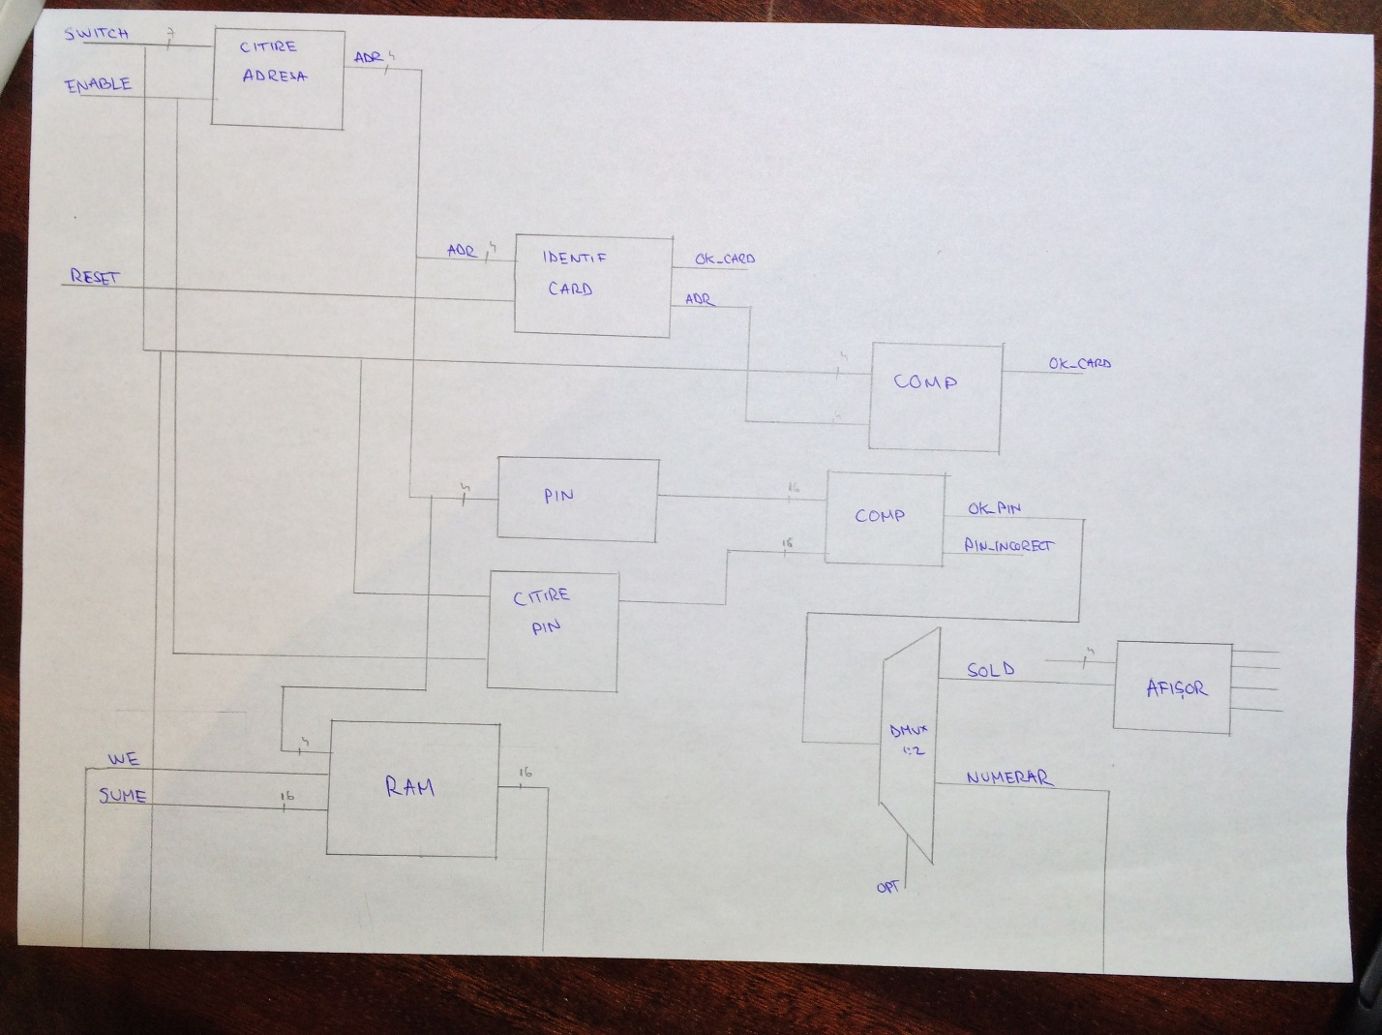

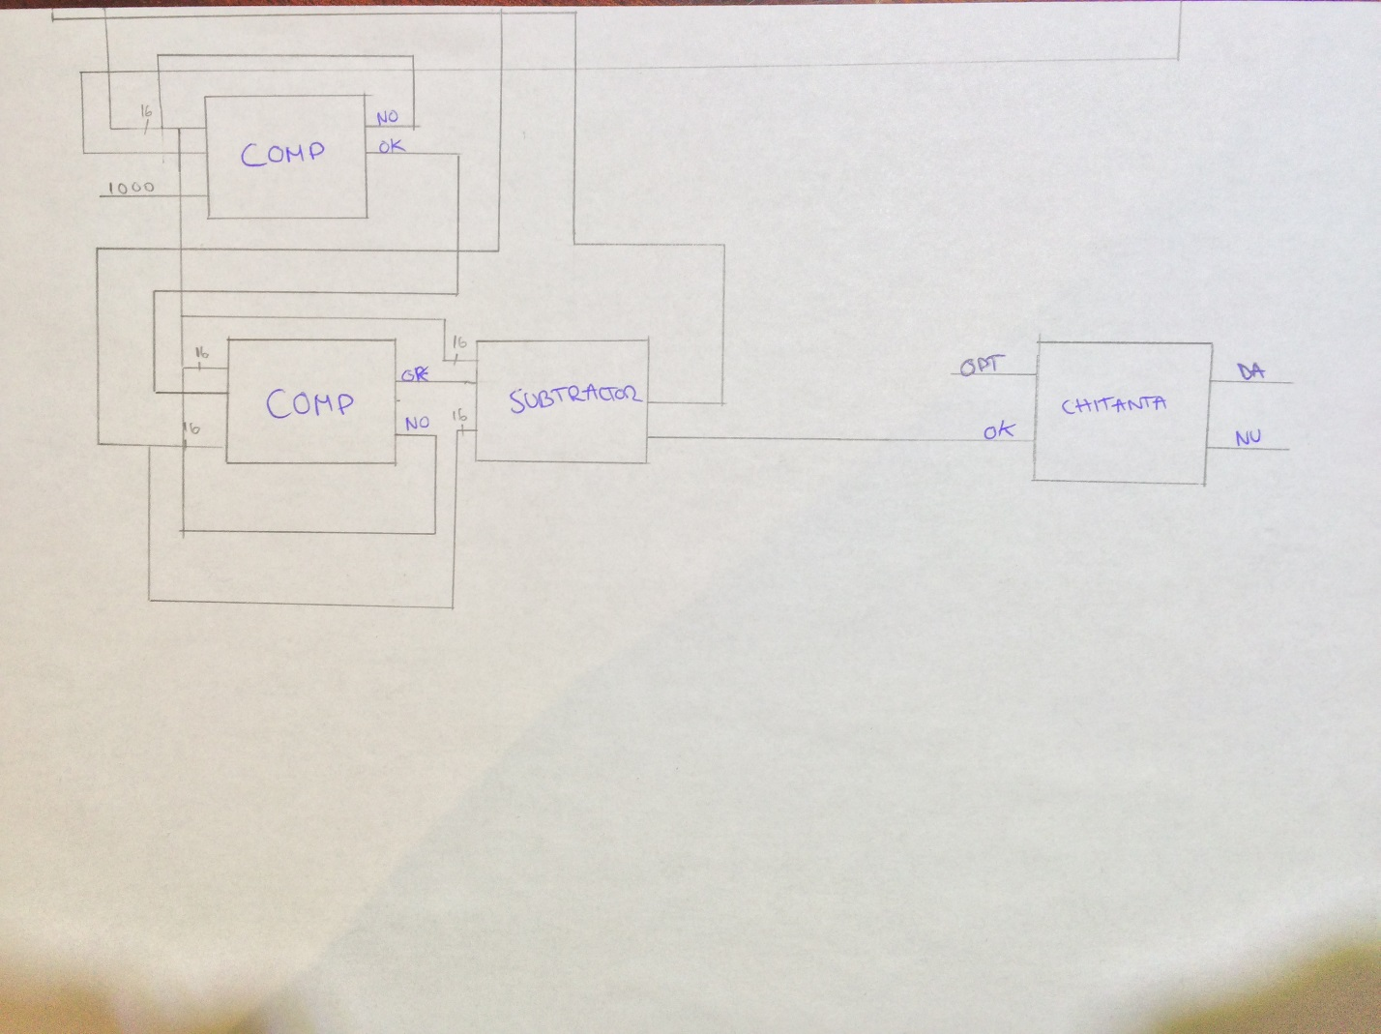

2.2 Block Diagram Analysis

We enter an address in “Citire Adresa” block and we compare it with the one in the memory and if it is ok we move on the the PIN Comparison unit which compares the PIN code introduce by the user with the one in the database using the “COMP” unit and the Rom memory “PIN” unit.
If the PIN code is valid we move on if not we will try again. Next is the DMUX which will allow us to choose between Balance and Cash Withdrawal. If we choose Balance we will see the Cash Balance on the 7 segments BCD Decoder and if we choose Cash Withdrawal we start the 2 comparisons. One with the max sum allowed and one with the current cash in the ROM memory. If everything is ok we move forward to the Subtractor unit which does the math and if the operation was successful we ask for the Receipt, or not. If it’s not we try again until we succed.
This cycle is finished when the Receipt unit is done.

3. Components
1. Card Identifier:
This component associates an address for each client using a 4 bit vector. It verifies if the address exists in the memory and if it doesn’t a led will notice us.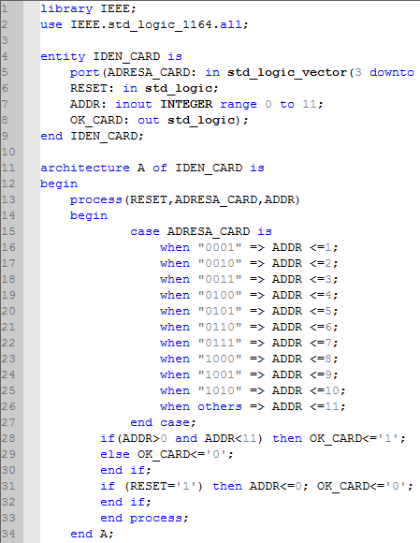

2. ROM Memory
We use a ROM Memory to store our clients’ PIN codes which will be later compared with the ones introduced. They will be stored with the corresponding address on 16 bits.

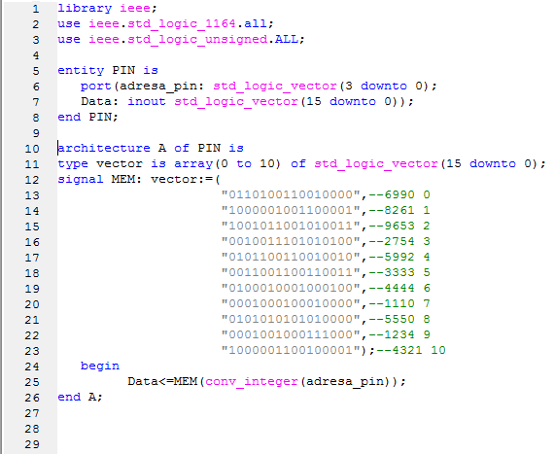

3. RAM Memory
Each client that has an address has also a cash deposit which is stored in this RAM Memory. And also if we activate “WE”-write enable it will update the cash after a transaction is done and the output will be on 16 bits.

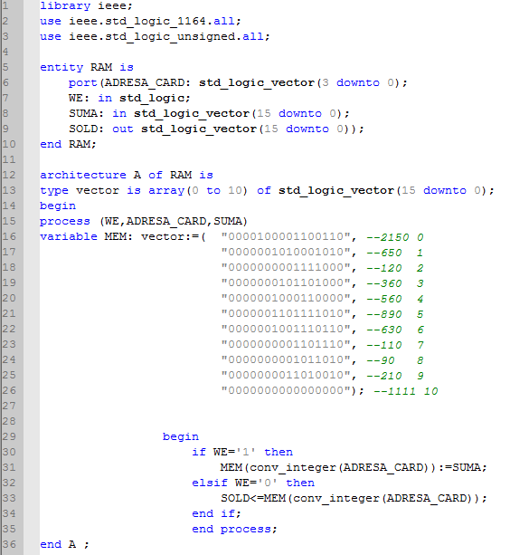

4.Demultiplexor

We need a demultiplexor to choose between our only 2 options:
-‘0’ for cash withdrawal(RN) ;
- ‘1’ for cash balance(S);
The demultiplexor is activated only if the introduced PIN code is correct.
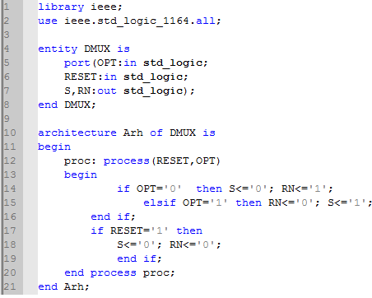

5.BCD 7
If the client has selected the cash balance option, then this component shows the amount of money from the current sold on the BCD 7 segments.
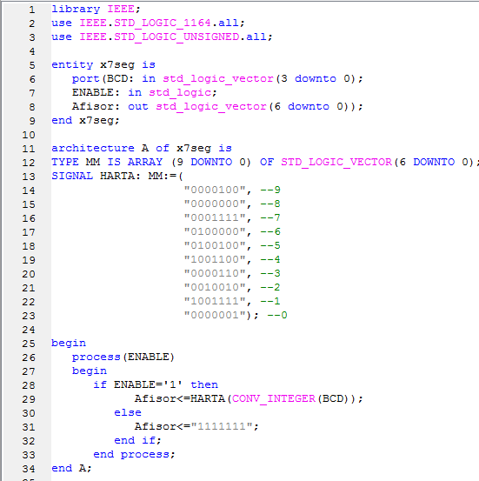
6.Comparators

6.1 Integer Comparator
It compares 2 integer numbers. We use it to compare the address introduced from the switches with the ones that are already stored in our memory and the result will be displayed on a led.
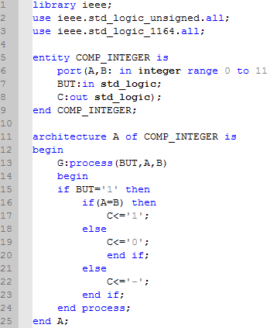

6.2 PIN Comparator
We will use this 16 bit comparator to check if the PIN code introduced from switches will match one of the ones we already have in the ROM Memory and if it is valid, we can proceed to the next step. This unit compares the information bit by bit.
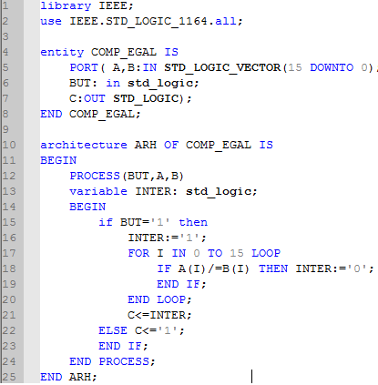

6.3 Sum Comparator
We can use this next comparator to check if the sum introduced by the user is smaller or equal to 1000 and if it is smaller than the cash in the persons’ account. The input is on 16 bits but it is converted to integer for an easy comparison and its output is essential if we want to move to the next step.
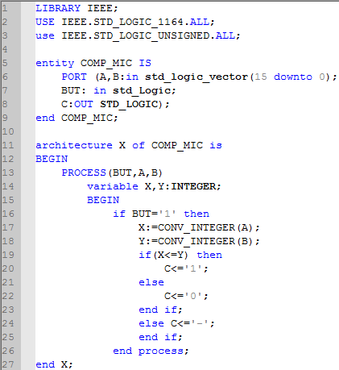

7.Subtractor
This unit is used to make the substraction between the sum introduced and the sum that exists if it is possible. It is done by converting to integer and then back to vector.
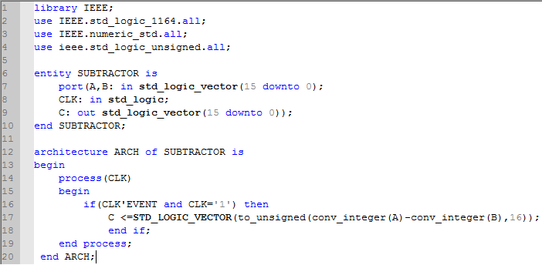
8.Receipt

If the client has selected “cash withdrawal” then it also has the option to choose a receipt in order to find the amount of money available in its sold. The options are:
-‘1’ for receipt;
-‘0’ without receipt;

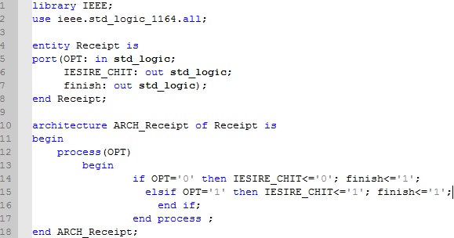

9.Registers
We are using registers to help us read the PIN codes, the sum and the card addresses because we choose to use all the 8 switches and we need them twice since there are 16 bits for PIN and SUM.

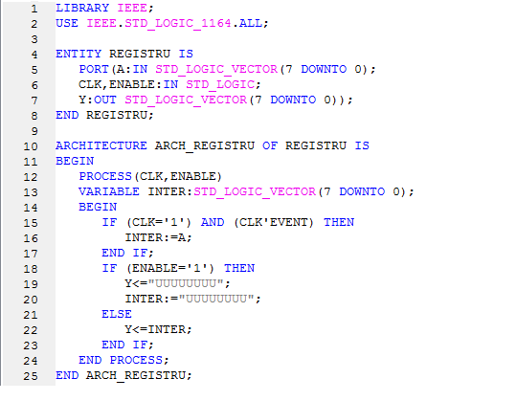

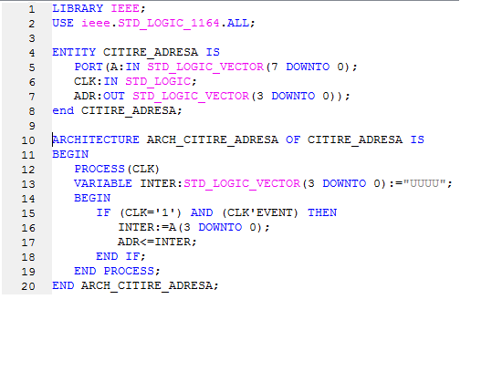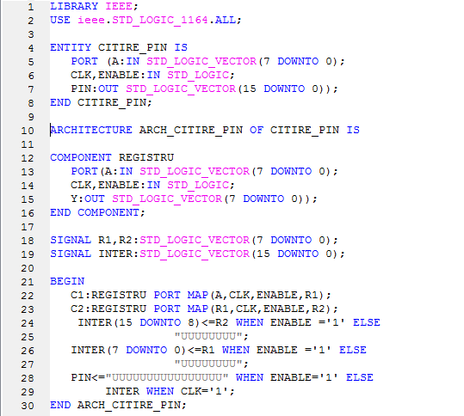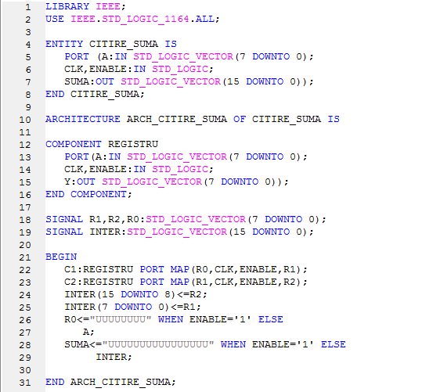

4. Justifying the chosen solution

We have chosen this solution due to its easy way of implementation. Since the project is split in components, it becomes easier and faster to understand it. It is also efficient whether an error might occur.
It is also quite similar to the reality owing to its logic order of the operations. A real ATM reads from the card’s magnetic line its unique number which corresponds to our address. After the right introduction of the PIN code, the ATM expects from the client to choose an option: cash withdrawal or cash balance. After the operations are executed, the client is able to ask for an optional receipt.

5. Instructions
For this ATM to work in Xilinx a certain number of steps must be taken into account. All of our components are linked in a top-level unit that reunites all the components and all the signals and processes.
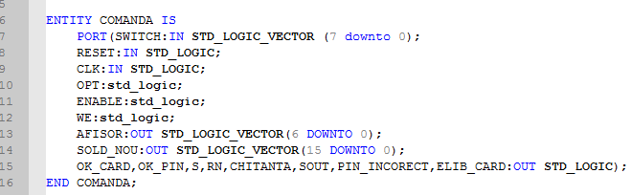

These are the inputs and the outputs of our ATM. The outputs are leds and the inputs are either the switches from the FPGA Board or the Buttons.
On the “SWITCH” input we will introduce the sum, the address, the PIN code. With the “OPT” input we will choose the DMUX’s options and the Receipt options. The input “Enable” is used to put some of our components in function and the “WE” input is used to write in the ROM Memory.

We choose to combine the inputs, outputs and components in a list of processes
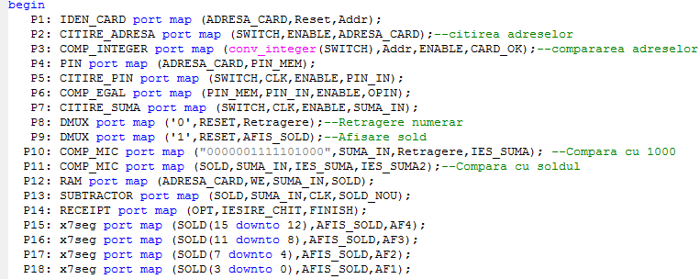

FPGA Description(Nexys 3)

NET "SWITCH(0)" LOC="T10";
NET "SWITCH(1)" LOC="T9";
NET "SWITCH(2)" LOC="V9";
NET "SWITCH(3)" LOC="M8";
NET "SWITCH(4)" LOC="N8";
NET "SWITCH(5)" LOC="U8";
NET "SWITCH(6)" LOC="V8";
NET "SWITCH(7)" LOC="T5";
NET "OK_CARD" LOC="T11";
NET "OK_PIN" LOC="R11";
NET "S" LOC="N11";
NET "RN" LOC="M11";
NET "CHITANTA" LOC="V15";
NET "SOUT" LOC="U15";
NET "PIN_INCORECT" LOC="V16";
NET "ELIB_CARD" LOC="U16";
NET "ENABLE" LOC="C4";
NET "OPT" LOC="A8";
NET "CLK" LOC="V10";

6. Possibilities for further development

Our ATM is created only on a small scale. It can be developed on bigger memories, more PIN codes and a larger amount of money.
The solution chosen by us has only 2 options: cash withdrawal and cash balance. The ATM might also contain the changing of the PIN or bank transaction. Usually, the device asks for a certain language, operation that we didn’t take into account. It can also be improved by using multiple bills. (different combinations of the existing euro bills).

